At Start of Day
- Turn on the power strip above box #4 for 2CAP. Turn on power strip for each set of 4 boxes for DD. This should provide power to all Pis and the MED-PC controller box.
- Power up the Pi server computer and log in (Username: lapishla, Password: Normal lapishla group password).
- Wait ~1 minute for each of the Raspberry Pis to power on and have IP addresses assigned (displayed in popup).

For each experimental session
- Click Start Experiment.
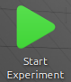
- Cssh will open a terminal to each Pi and set it’s clock time. Hit enter to close windows.
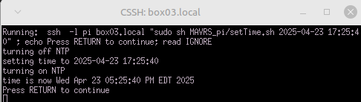
- Cssh will open a terminal to each Pi and report current disk usage.
  - If less then 20 GB of free space remains on any pi, abort experiment startup, transfer data from the Pis to the server, and delete data from the Pis to free up space.
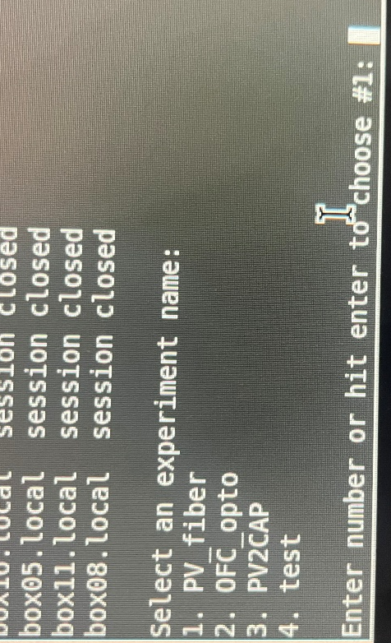
  - Otherwise, hit enter to close the terminal windows.
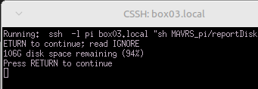
- Choose the experiment name when prompted by entering its number identifier.
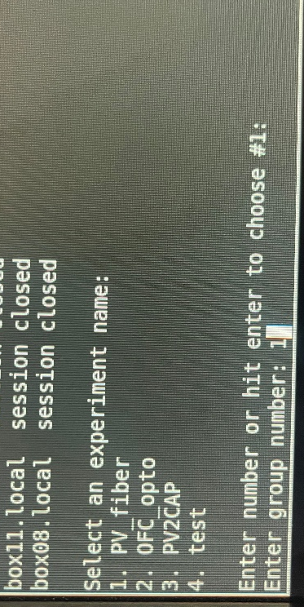
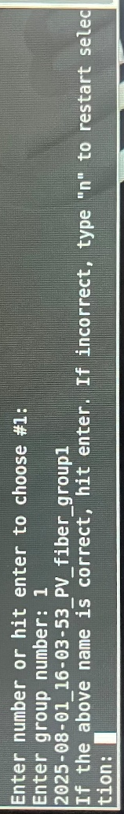
- Enter the group number for the day.

- Hit enter to accept the suggested name or type “n” to go back to the start of the naming process.

- The Pi Server computer will connect to the MED-PC computer and create a session folder at C:\data\session\med-pc_session, where session is the name you just approved.
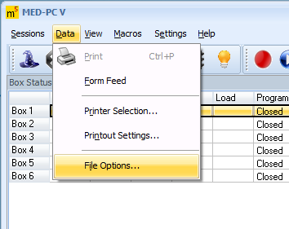
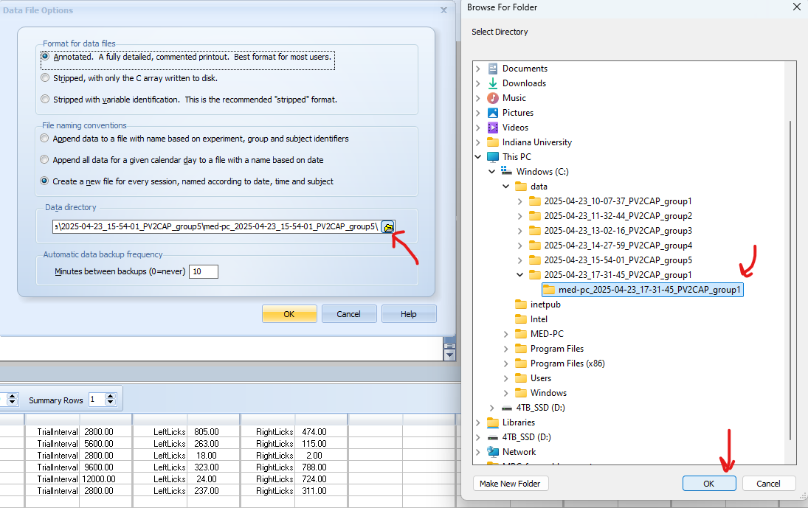
- Change the MED-PC save location to the newly created session folder by clicking data → File options → data directory.
  - If any errors occur and this folder wasn’t created, continue with the experiment, and manually create a folder on the Med-PC computer. After the session, you will then need to ensure all data is transferred to it’s proper location on the pi server. Try running the WSL keep alive shortcut on the MED-PC computer, if the Pi Server Computer is having issues making an SSH connection to the MED-PC computer
- Enter the medPC program for each animal. Load each animal into their boxes
  - Check additional protocols for instructions: stepByStep_DD_protocol, Katie DD Protocol
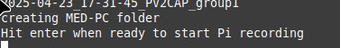
- Return to the Pi Server computer and hit enter to start the pi recordings. Cssh will open a terminal windows to each pi to run the startup scripts. Feel free to close these windows as the scripts will continue running independently on the Pis in the background. Alternatively, leave open to view any error events.
- Issue the medPC programs.
- Wait for experiment to end.
- Click Stop Experiment button on Pi server computer when behavior is over
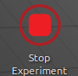
At End of Day
- Run Transfer Data from Pi to Server to move data from the Pis and the MED-PC computer to the piData folder on the Pi server desktop.
  - Alternatively, you can run this script between each session to speed up transfer at the end of the day.
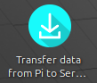
- Run Backup to Datastar to backup the contents of the piData folder to Datastar:research/behavior_rooms/2cap/.
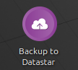
- Once all data has been transferred to the server PC and has been copied to datastar, Delete data on Pis.
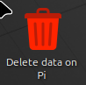
- Shutdown Pis
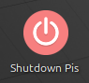
- Turn off the powerstrip above box #4

